# Summary of Changes

1. **DOLWIN-1307**: **Add “Qtrly Totals by Own by Cov” report in the “File” group so it is available to all states.** The report shows the quarterly totals by Ownership and Coverage for the year chosen. After running the special procedure to add the report, you will see it here:

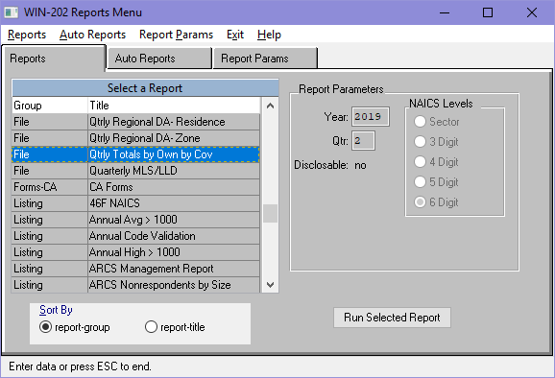

1. **DOLWIN-1277**: **Update Wage tool to exclude certain SSNs.** To improve performance when creating the wage files from the WIN202 Wage Tool, exclude the following bad SSNs from the pred/succ relationship piece (but leave them included in the wage accumulation piece)
   1. Any of these:  111111111,222222222,333333333,444444444,555555555,666666666,777777777,888888888,999999999,123456789,987654321
   2. If the 4th and 5th values of the SSN on the load line are “00”
   3. If the last 4 digits of the SSN on the load line are “0000”
2. **DOLWIN-1276**: **Exclude the “Status Code” field from being updated in WIN if it is on the QUEST quarterly load file.** The ‘status code’ field is a column in the QUEST WIN202 quarterly load file. If a value is in that position in the load file, it is currently put on the WIN202 quarterly line for the account. This change will eliminate that function. The field in WIN202 will no longer be updated with any value for the ‘status code’ that may come in on the load.
3. **DOLWIN-1275**: **Some accounts are not loading properly in the EDI load.** This is because there are predecessor/successor data lines for the UI/RUN being loaded that are all referencing the same UI/RUN. This is causing the status log to see multiple lines that are the same and it puts errors in the output file. This has been fixed so that duplicate lines are no longer seen, and the errors no longer appear.
4. **DOLWIN-1274**: **Update the “Bad Character” check to decrease the size of the resulting ‘clean’ output file.** The ‘clean’ output file size has been reduced to more accurately reflect the actual size of each line in the output file. Prior to this change, each line in the output file was 1000 characters, even if most of the line was blanks. This made the output file unnecessarily larger than it had to be. This change has no effect on the data in the output file or the time it takes to create or load the resulting ‘clean’ file.